SkillCourt Backend

Andy Martinez & Matthew Santiago

Florida International University

Senior Project

**Legal Notices**

Table of Contents

Introduction: 4

1. Android Application: 5

2. Microcontroller Arduino: 7

a. Setting up Arduino pins: 8

3. Website: 9

4. Using GitHub: 10

5. Processing: 11

## Introduction:

This document will provide a comprehensive set of steps that allow any developer to set up the environment in his development machine in order to start working with the SkillCourt application. This guide also includes a comprehensive set of steps to run the application and test it in a simulator or a real Android device, as well as a list of the technologies that need to be installed in order to keep moving forward developing this application. Additionally, it includes step-by-step information of how to access and run the SkillCourt website in the development machine. There are also be instructions that will help in the development of the Arduino microcontroller. Lastly, instructions of how to get the current SkillCourt Project from Github are included

## Android Application:

1. The first step to start dealing with any android application is to install Android Studio. In order to accomplish this task navigate to the following link <http://developer.android.com/sdk/index.html> . Then click “Download Android Studio”. Accept the terms and conditions.
2. Once the download process is completed, double click the application and follow all the steps that will be appearing on the screen.
3. Once the application is installed, proceed to install the necessary SDKs. Click “Android SDK Manager”. In there, select Android 5.0.1 (API 21) as well as (API 20) and (API 19). The click “install packages”, accept all terms and conditions and wait until they are installed.
4. To install a simulator in order to test the code that has been developed so far, click on the “AVD Device Manager” icon. Once the window opens, click on “Create Virtual Device”. In the new window enter all the information about the device you are creating like type, name, RAM, Disk space, screen size. Click “Create Device” and a new device with the specifications provided will be created.
5. In order to run one of the devices that has already been created, go to AVD Manager and look for the device you want to execute. Once you find it, click run.
6. In order to use a real Android device instead of a simulator, connect you device to the computer running Android Studio and allow development mode in your android device.
7. To run the current project in either a simulator or the actual Android device, click the Run button in Android Studio. Then, select the device in which you want to run the project and then press ok. Note: If using a real Android Device, it must be connected via USB when you click Run.

## Microcontroller Arduino:

1. In order to be able to work with Arduino navigate to the following webpage: http://arduino.cc/en/main/software.
2. Then, select the operating system running on your development machine and click download.
3. Once you have Arduino IDE running in the development machine, connect your Arduino to the computer via a USB connection.
4. Once code is written, press run and select the Arduino microcontroller in which you will be running the code.

### Setting up Arduino pins:

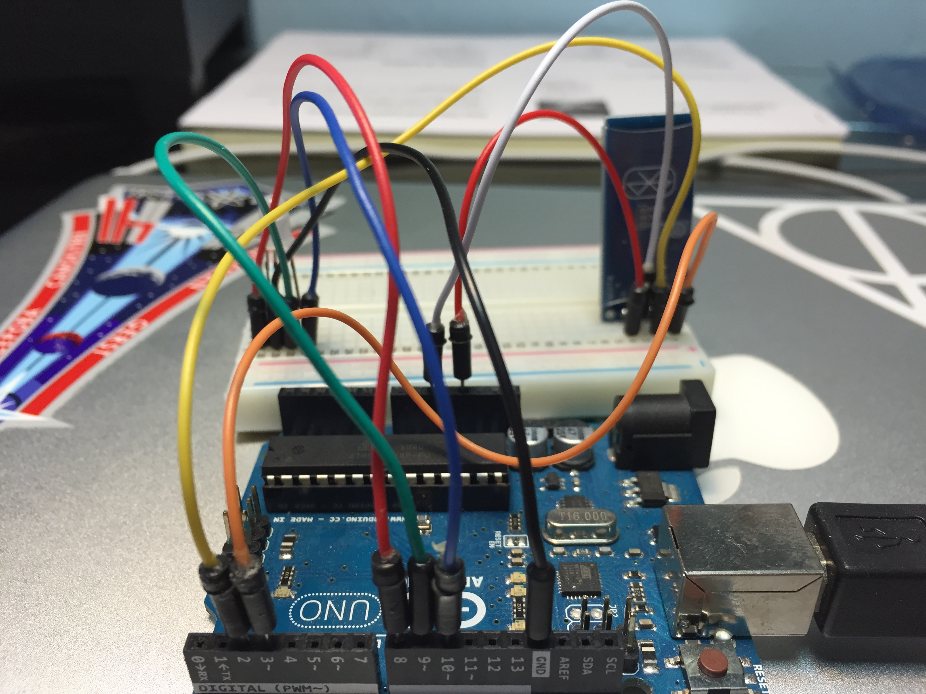

|  |  |
| --- | --- |
| Connections between Arduino pins and Bluetooth Module pins: | |
| Arduino pins | Bluetooth module pins |
| 5V | VCC |
| Ground | Ground |
| 2 | TXD |
| 3 | RXD |

|  |  |
| --- | --- |
| Connections between Arduino pins and LED pins: | |
| Arduino pins | Bluetooth module pins |
| 8 | Red LED pin |
| 9 | Green LED pin |
| 10 | Blue LED pin |
| Ground | Ground |

## Website:

1. In order to create and develop a website in the development machine start by installing lamp server. Use the following commands:

* sudo apt-get update
* sudo apt-get install lamp-server^

1. Once the server is installed also a copy of MYSQL DBMS will be installed in de development environment.
2. Proceed to install phpmyadmin :

* sudo apt-get install phpmyadmin

1. In order to start writing code navigate to the html folder using the following command:

* cd /var/www/html

1. In order to work with MYSQL database use your browser to navigate to “name of your development machine”/phpmyadmin. Enter your credentials and then press go.
2. In order to see the actual website, use your browser to navigate to “name of your development machine”

## Using GitHub:

1. Start by navigating to GitHub main page.
2. Enter you credentials and login.
3. Once you are given access by professor Masoud, you will be able to download the current SkillCourt project. Click in download in order to get the entire SkillCourt Project.
4. Once you have all the files navigate to the Code folder.
5. When you are inside the code folder, you will see the Android Studio project.
6. Copy the Android Studio project inside your local Android Studio directory.
7. Then refresh or reopen your Android Studio program and you will be able to see a new project called SkillCourt.
8. Select the SkillCourt project and the entire project will be displayed in Android Studio.

## Processing:

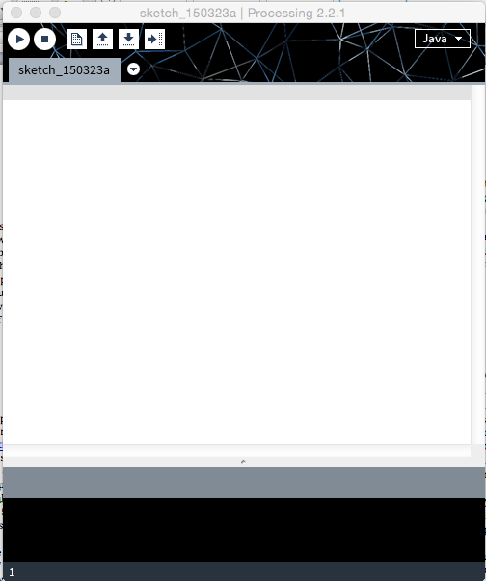

1. Go to [www.processing.org](http://www.processing.org).
2. Download processing
3. Double click the icon and follow steps
4. Write your code and it is ready to be compiled